Entrust Private

Tech Tip ID: MX Series-511 |  |  |  | Release Date: 3/13/2026
Author: Sebastian White |  |  |  | Revised Date:
Additional Tech Tips and Driver downloads can be found at
https://trustedcare.entrust.com/
(A username and password are required to log onto the web page)
DATACARD MX Series Systems:
MX9100 | MX8100 | MX6100 |  | MX2100 | MX1100
X | X | X |  | X | X
PB8500 | PB6500 |  |  |  | DX5100 | DX3100
Module: UV Cure\ Cardgard |  |  | Controller: All
Subject: PFN – Reset switch

Problem Statement: MFG has identified there are PFN’s in the field that have a different style circuit breaker (809601-015). When in a depressed (open circuit) state, you may have low voltage errors.
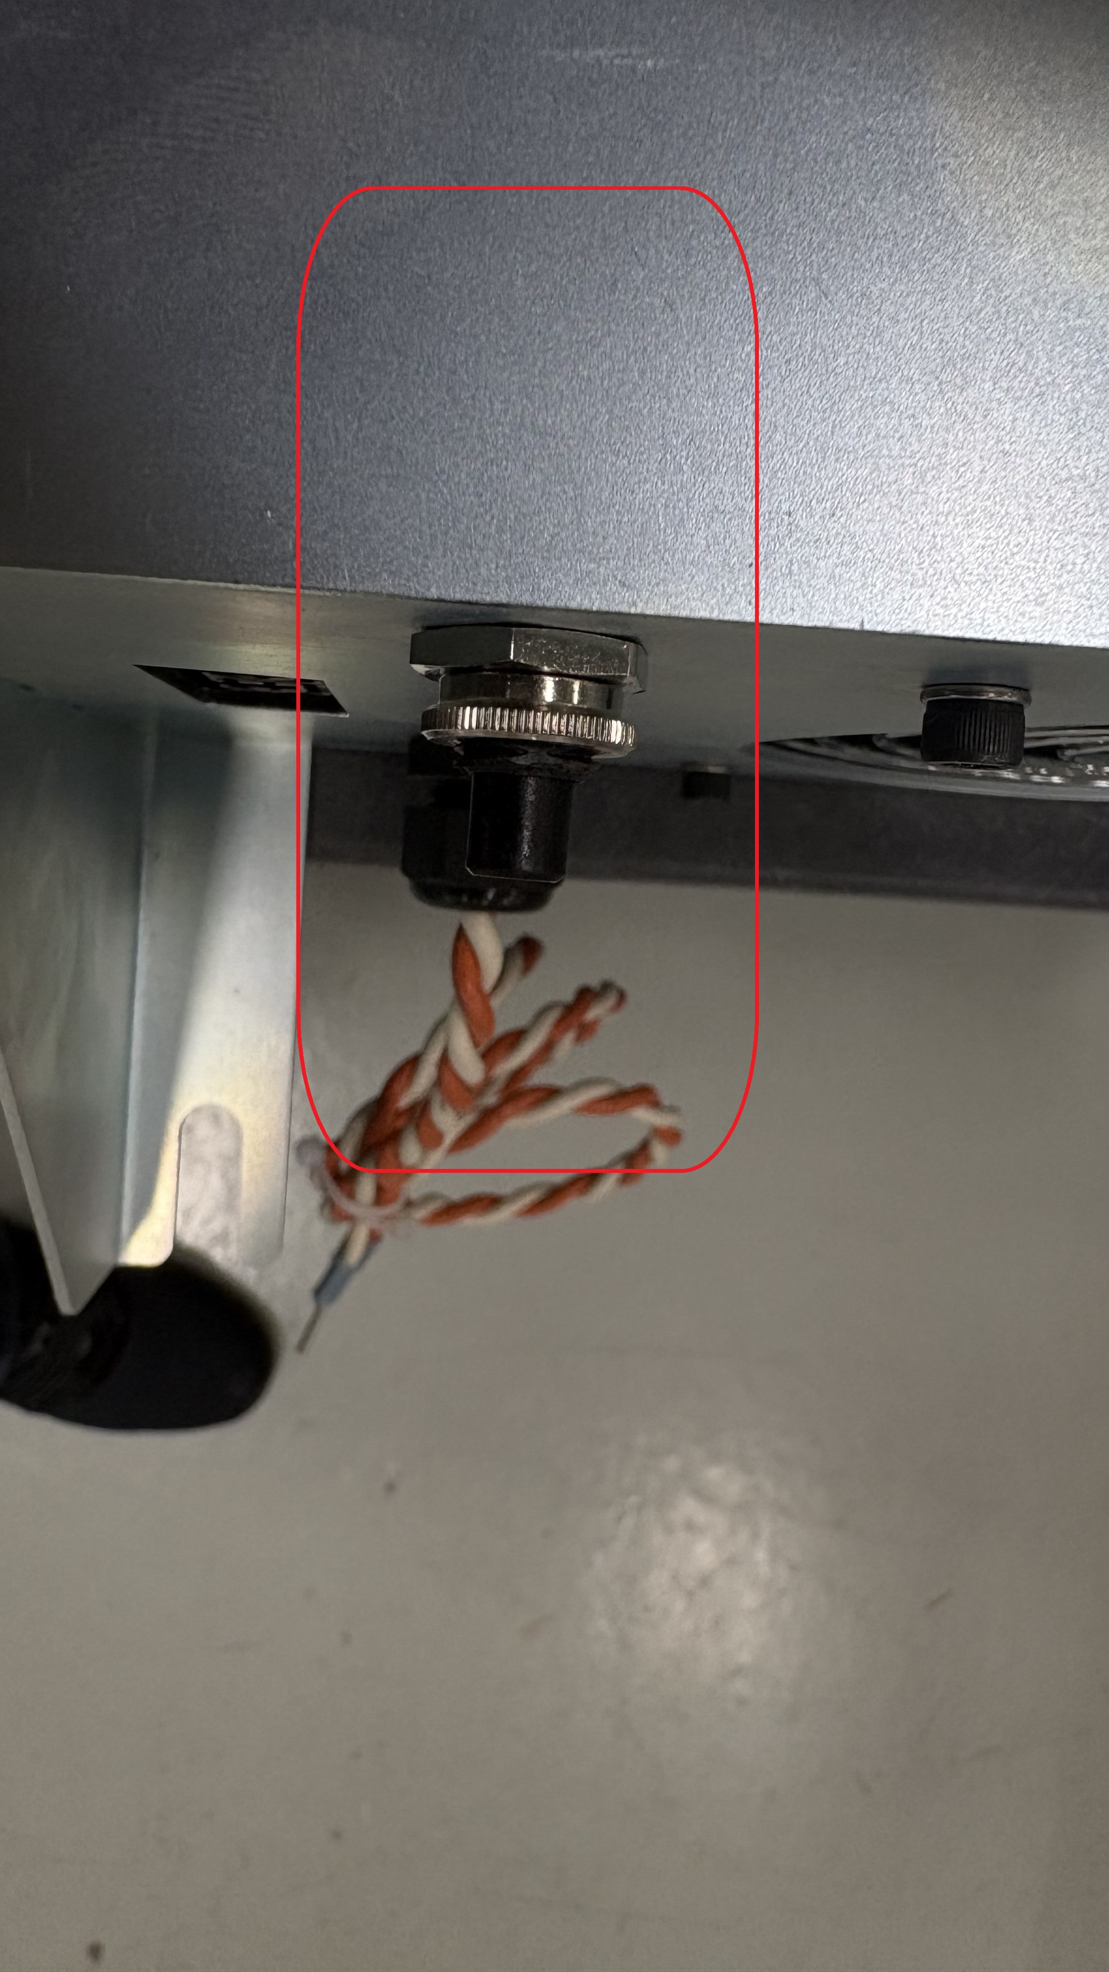
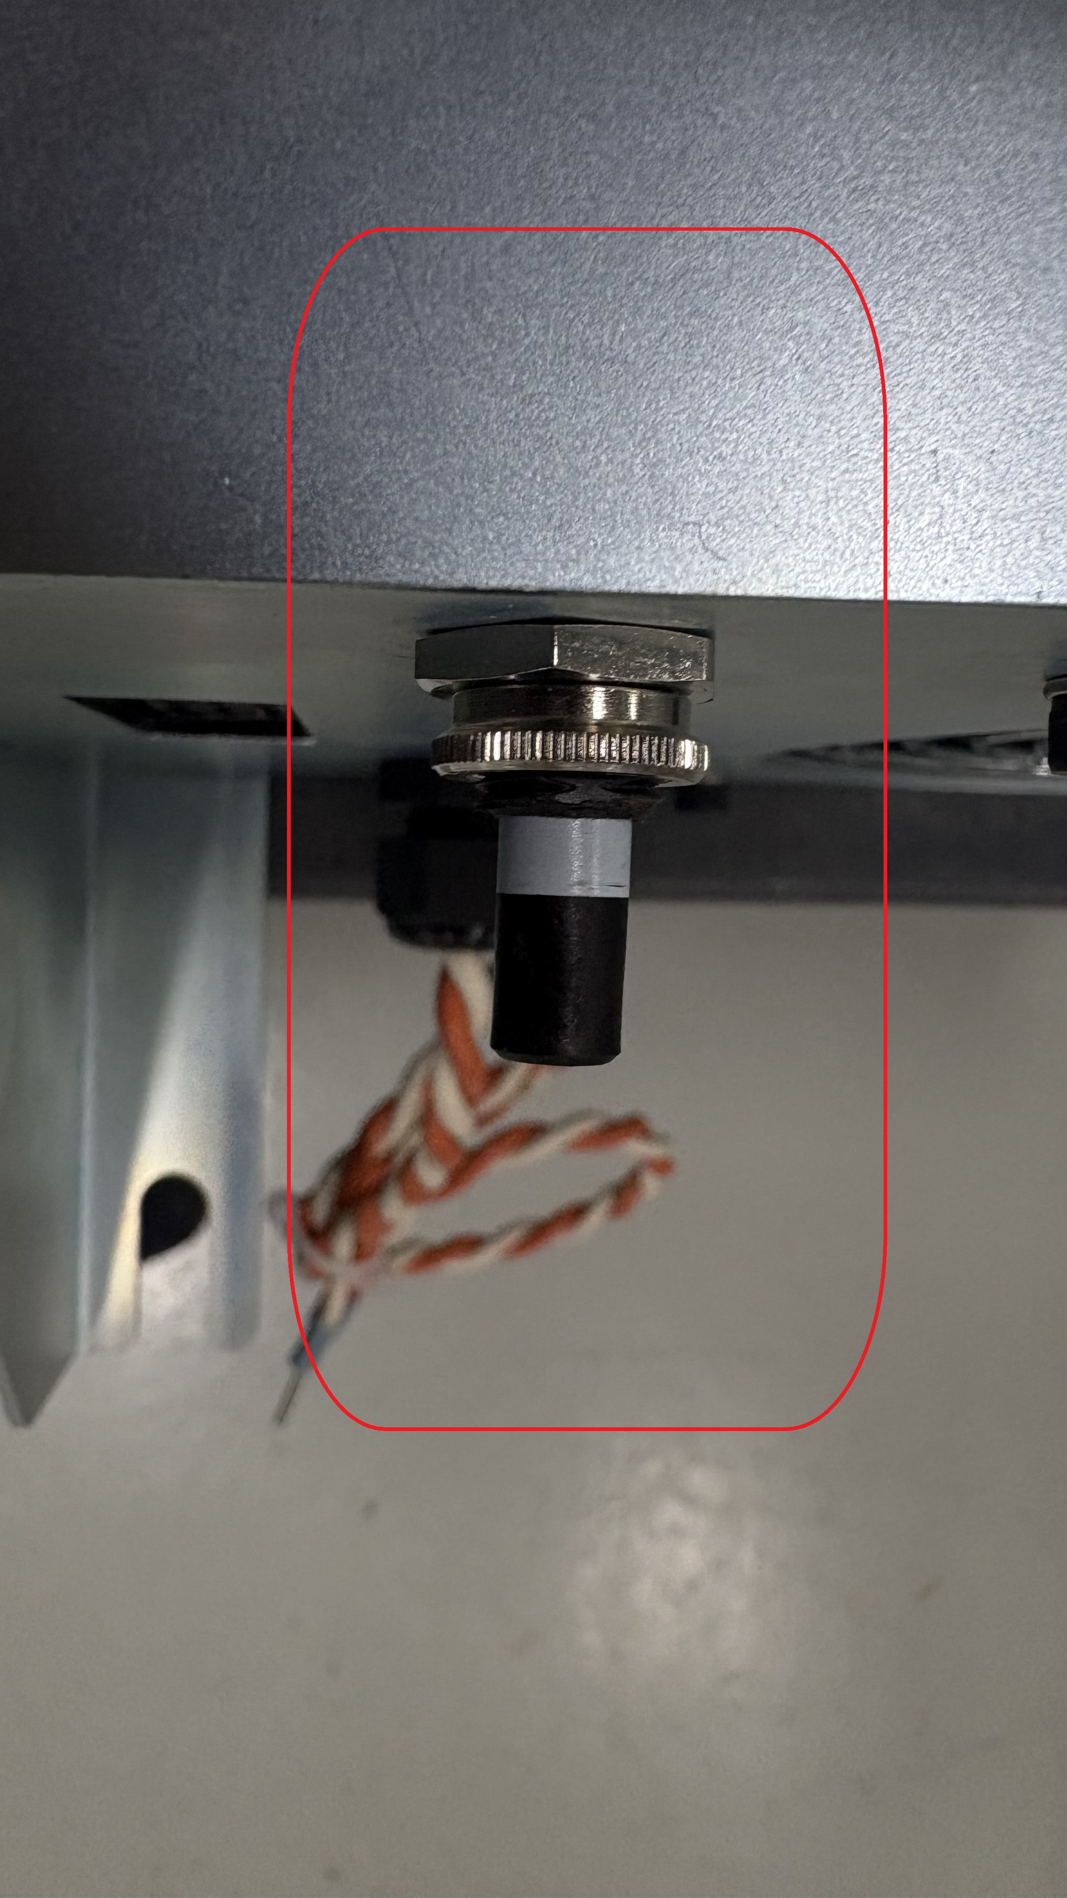
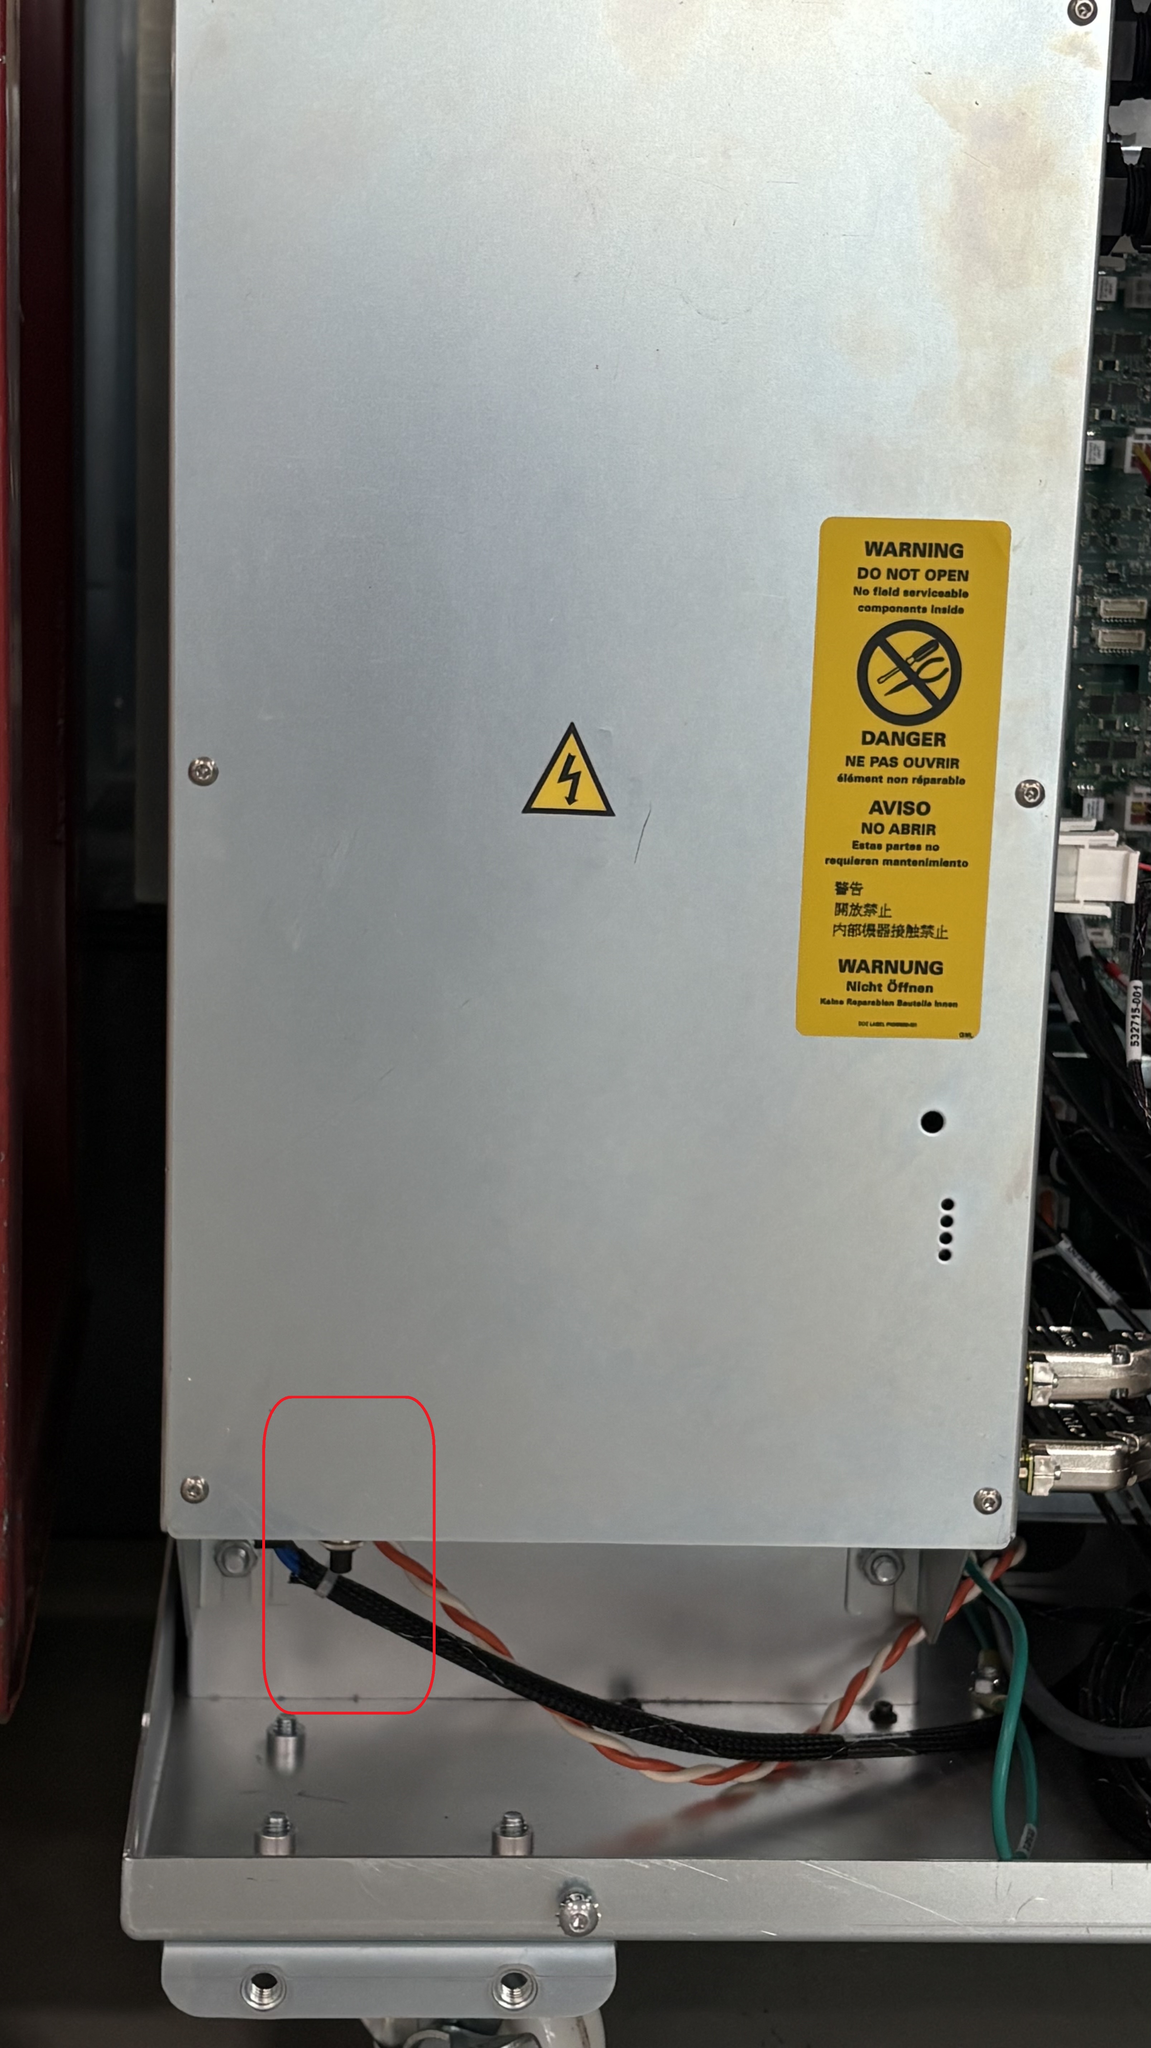
Module view Depressed (open circuit) Pressed (working position)

Solution: Ensure the circuit breaker is in the closed (pressed) position. Please note, when the switch is depress it will appear longer exposing a white band, this indicates that the circuit is open. The item is used in both modules and FRU’s

FRU’s
Cardgard = 575872-001
UV Cure = 523448-001

